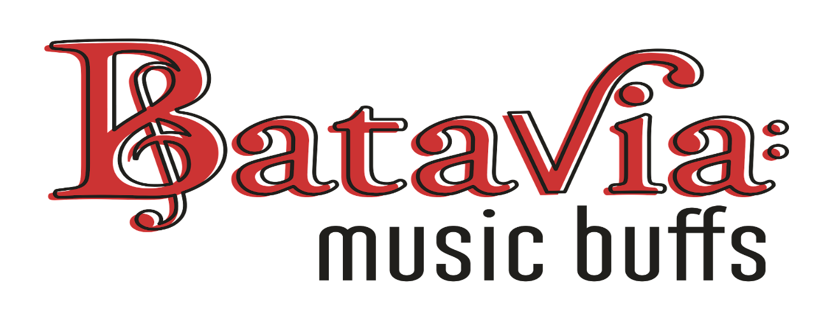Presents

Sunday April 21st, 4:45pm - 9:00pm
Batavia Moose Lodge
Register teams of 6-8 at
Trivia Night - Team Registration | Batavia Music Buffs

Early bird rate: $160 per team before Sunday, Apr. 7th
$200 per team after Apr. 7th

