Batavia Music Buffs

Invites you to

Fundraise with us when you do your holiday shopping!

**RaiseRight: Simply the right way to fundraise.**

Raise funds for the Batavia Music Buffs by buying gift cards from RaiseRight to pay for your everyday shopping and spending year-round. Groceries, dining out, home improvement, and everything in between. It’s the most convenient and effective way to fundraise because earning becomes part of your everyday life. Plus, gift cards are great for helping you to set and keep a weekly budget.

It's never been easier to create opportunities for what matters most to you. No extra money spent. No extra time wasted.

**How it works:**

* Buy gift cards at full value from 750+ brands. Pick from eGift cards and physical gift cards.
* Music Buffs will earn up to 20% on every gift card you buy.
* Use gift cards at full value for your everyday purchases.
* Watch your fundraising dollars grow through the year, thanks to the brands that give back to support your community!

**Get started today!**

Create a free fundraising account on [the](https://www.myscripwallet.com/home) RaiseRight mobile app or at RaiseRight.com and use the enrollment code 1Q1JMEF5TXMP

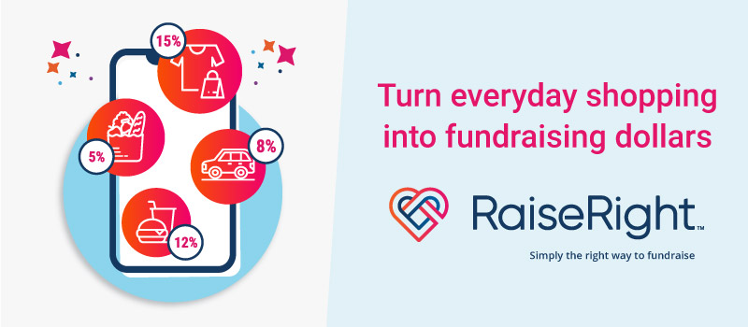Questions? Contact: Holly Miller [VPWaysandMeans@Bataviamusicbuffs.org](mailto:VPWaysandMeans@Bataviamusicbuffs.org)