You are invited to
Family Reading Night with the Judges
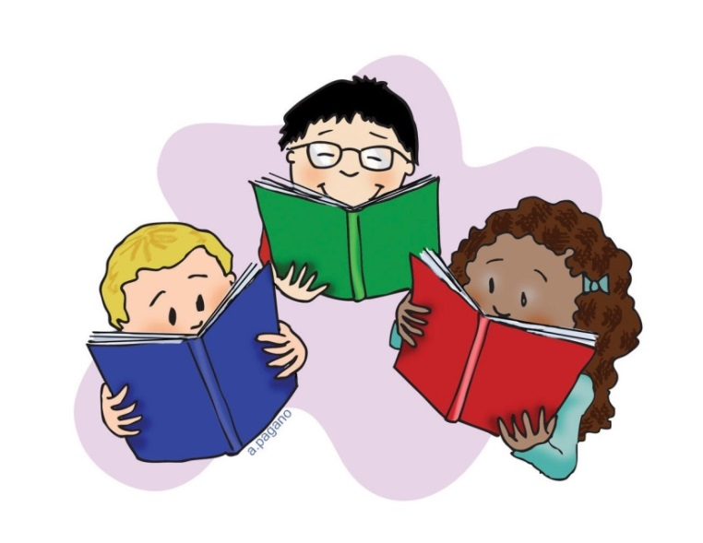

Who? Judge Tracy, Judge Sarang and Judge Parga would like to read their favorite bedtime stories to YOU*! Event includes snacks and a courtroom tour. Don’t forget to bring your friends!
*This event is for children in 2nd grade or younger accompanied by an adult.

Where? Kane County Law Library & Self Help Legal Center
2nd floor of the Kane County Judicial Center
630.406.7126

When? Wednesday, November 15th, 2017
6:30pm to 7:30pm

Attire? Pajamas, of course!

