B-PAC Meeting Agenda 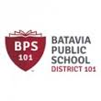
October 19, 2015

- Welcome and Introductions

2) Power Point Presentation with overview of EL Program in Batavia

3) Introduction of Guest Speaker Teresita Barbosa of TriCity Family Services

4) Preview of Upcoming Events

5) Questions

