B-PAC Meeting Agenda 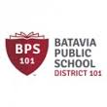
March 16, 2016

- Welcome and Introductions

2) Power Point Presentation with overview of Assessments: ACCESS, MAP and PARCC Testing and Your EL Student

3) Introduction of Student Support Tools including iStation Espanol

4) Preview of Upcoming Events- Multi Cultural Event

5) Questions

